**ASSIGNMENT-2**

-submitted by **Dinesh kumar Kunchala** Date:09/04/2023

Step1: Create Java Project.

Go to **file->new->project..->java->java project** and give project name and click on finish.

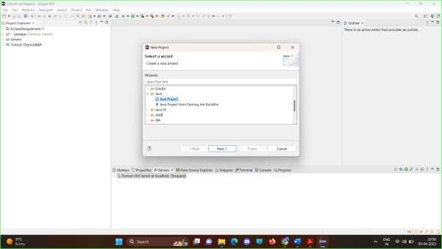

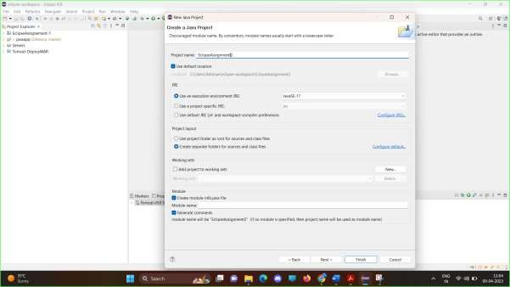

Step2: Create a class Calculator.java.

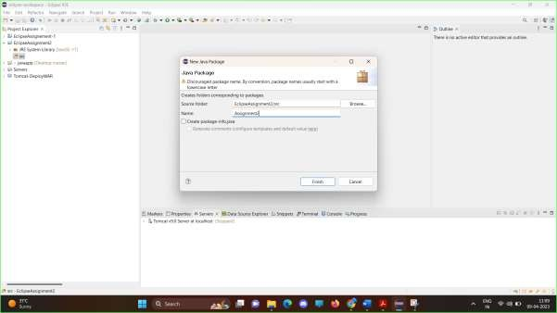Create a new package by right clicking on **src->new->package** and give package name.

Right click on **package ->new->class** give new class name and click on Finish.

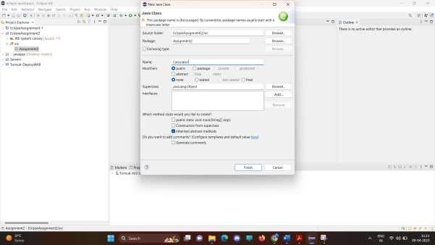

Step3: Write 4 public methods for (Sum, Subtract, Multiply, Divide).

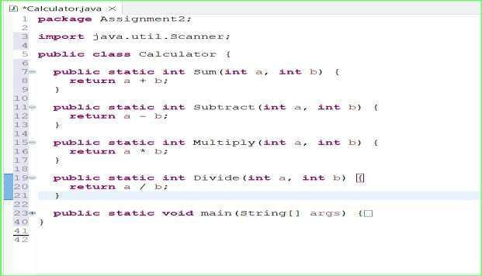

Step4: Each method takes 2 integer values as input .

In the image above input a,b are integer parameters for methods. Step5: Read input from the console.

Scanner Is used to read input from console.

Step6: Write the main method to read 2 input values from terminal.

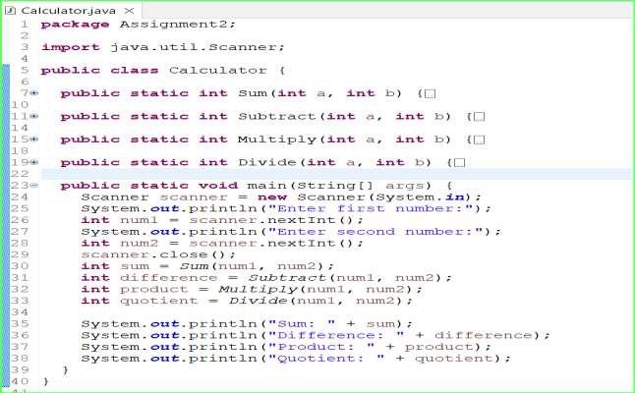

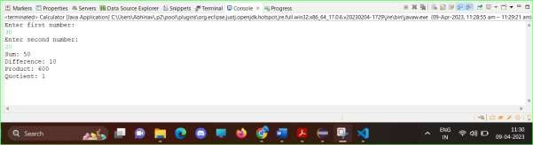Step7: Call all the methods and print the output of the methods. Right click on click on run.

Step8: Import the Junit jar.

Right click on package new->junit->junit Testcase and give project name as Calculator Test and include junit in project.

Step9: Write the Junit testcases for each of the 4 methods.

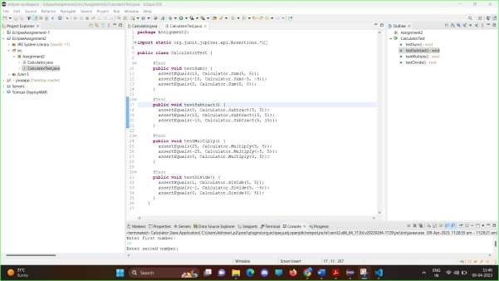

Step10: Run the test cases to validate the method output. Click on run->run as-> Junit Test.

